

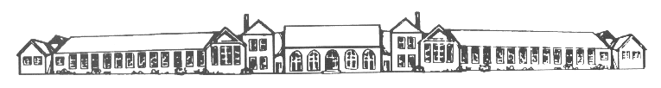
We aim to develop a supportive partnership here at Birtley East between our children, parents and the school.
As pupils we expect you to:
Do as you are reasonably asked by any adult in school.
Attend school every day and be at school on time every day.
Wear your school uniform and look smart.
Always try your very best.
Do your homework and always hand it in on time.
Look after our school equipment, building and environment.
Follow our school rules.
Be kind, friendly and respectful to everyone - children and adults – in school, out of school and when using the internet and social media (such as Facebook).
Take responsibility for your own actions.

As parents we expect you to:
Make sure your child arrives in school on time every day.
Make sure your child attends school every day and contact school promptly if they are unable to attend.
Ensure that every day your child wears full school uniform and is wearing no jewellery.
Attend each parent’s evening and any discussions about your child’s progress.
Support your child with their homework.
Support the school’s high expectations of behaviour of children and adults both whilst on school grounds and whilst using the internet, including using social media such as ‘Facebook’ responsibly.
Talk to school about any concerns or problems that could affect your child’s behaviour or well being.

Our school will:
Care for your child’s safety and happiness in a secure and ordered environment.
Aim to develop every child to their full potential through a broad and balanced curriculum.
Encourage and guide every child to do their very best all of the time.
Support each child through regular homework in line with school policy.
Keep parents informed of progress through parent’s evenings and annual reports.
Keep parents informed through letters home, texts and via our website.
Keep in contact with parents, especially if there are concerns or problems with a child.

Please complete this form and return it to school, we will sign and retain the form, a photocopy will be returned to you.
Pupil’s signature:
Date:
Parent’s signature:
Date:
Head teacher’s signature:
Date:

