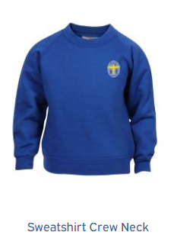**School Uniform Policy February 2023**

**Reception to Y6**

School uniform is important for lots of reasons. In particular, wearing uniform prevents children from feeling like they need to wear the most fashionable footwear/leggings etc to school. This can make a further demand on ever tighter household funds and can subject children to unnecessary peer pressure. Children wearing correct uniform each week will gain house points as a reward. **Children attending school without appropriate uniform or footwear may be given spare clothing and shoes to change into.**

Uniform requirements:

* Royal blue sweatshirt/cardigan – plain or with the school logo.
* White or yellow polo shirt – plain or with the school logo.
* **GREY** smart school trousers, skirt, shorts or pinafore. **No black items or** j**ogging bottoms, sports shorts or leggings.**
* Blue or yellow gingham dresses may be worn in the summer term.
* Black leather/polishable flat school shoes.
* All children need a red t-shirt or polo shirt and navy blue shorts for PE. Children need to bring plimsoles or trainers to change into for PE. Children can bring navy blue leggings or jogging bottoms to wear for PE when it is colder but should always have shorts with them. Children going swimming (usually year 5) will need swimming kit each week. PE kits should be brought to school each week on a Monday, they will be returned home each Friday to be washed over the weekend. *Children are placed in house teams and we ask parents to buy a plain t-shirt in their child’s house colour for sports day and other appropriate events. Siblings are placed in the same house groups.*
* Children need a pair of wellies and appropriate outdoor clothing in order to access our full play provision. *Children may change into their PE shoes to play outside if parents prefer but this will need to happen during breaktimes and not during lesson times.*
* Children may wear small stud earings that they can take out and look after themselves and may wear a wrist watch (NOT a smart watch). No other jewellery is acceptable. If children cannot take out their own earrings they must not wear them.
* Nail varnish and make up are not to be worn for school.

Items are available from [Birtley East Primary School Uniform Shop (pbuniform-online.co.uk)](https://www.pbuniform-online.co.uk/schools/birtley-east-primary-school.html?product_list_limit=all). Orders can be placed at any time and delivered to home or to school during term time. During the summer holidays, orders placed by 1st August will be delivered for the start of the Autumn term. We carry a small amount of stock in school if you wish to view sizes.

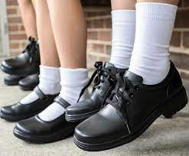**Reading Book Bags** All children are provided with a new school book bag when they join our main school (usually in reception class)*. These must be brought to school every day without fail.* If a book bag is lost or needs replacing families will then be asked to purchase a new one.

**Nursery** Children in our nursery are asked to buy clothes in our school colours. Most nursery children wear exactly the same uniform as our older children. Parents may consider which trousers/bottoms their children wear to nursery depending on their level of independence.