**School Uniform – how to order online**

[**https://www.pbuniform-online.co.uk/birtleyeast**](https://www.pbuniform-online.co.uk/birtleyeast)

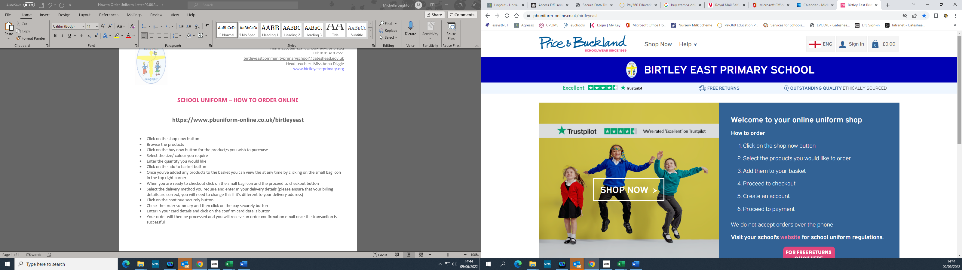

* Click on the shop now button
* Browse the products
* Click on the buy now button for the product/s you wish to purchase
* Select the size/ colour you require
* Enter the quantity you would like
* Click on the add to basket button
* Once you've added any products to the basket you can view the at any time by clicking on the small bag icon in the top right corner
* When you are ready to checkout click on the small bag icon and the proceed to checkout button
* Select the delivery method you require and enter in your delivery details (please ensure that your billing details are correct, you will need to change this if it's different to your delivery address)
* Click on the continue securely button
* Check the order summary and then click on the pay securely button
* Enter in your card details and click on the confirm card details button
* Your order will then be processed and you will receive an order confirmation email once the transaction is successful

**Sizes & Pricing**

|  |  |  |  |  |  |  |
| --- | --- | --- | --- | --- | --- | --- |
|  | **24”** Chest | **26**” | **28”** | **30”** | **32”** | **34”** |
| Cardigan (Blue)  (£11.00) |  |  |  |  |  |  |
| Sweatshirt (Blue)  (£9.50) |  |  |  |  |  |  |
| White Polo Shirt  (£8.50) |  |  |  |  |  |  |
| Blue Shorts  (£4.50) |  | Age5/6 | Age 7/8 | Age 9/10 |  |  |
| Red T Shirt  (4.50) | Age 3/4 | Age 5/6 | Age 7/8 | Age 9/10 | 11/12 |  |
| Fleece Jackets  (£15.00) | Age 3/4 | Age 5/6 | Age 7/8 | Age 9/10 | 11/12 |  |
| Reversible Coat  (Showerproof £19.50) | Age 5/6 | Age 7/8 | Age 9/10 | 11/12 |  |  |
| Book Bag  £5 |  |  |  |  |  |  |
| Iron on Name tags  (18 Characters) | £4.00 |  |  |  |  |  |
| PE/Swim Bag  £4.00 |  |  |  |  |  |  |
| Backpack  £10.00 |  |  |  |  |  |  |